Goalie

    #define FL_threshold 200

    #define FR_threshold 130

    #define LI_threshold 200

    #define LM_threshold 220

    #define LO_threshold 200

    #define RI_threshold 220

    #define RM_threshold 220

    #define RO_threshold 160

    #define BIL_threshold 120

    #define BIR_threshold 150

    #define BOL_threshold 100

    #define BOR_threshold 190

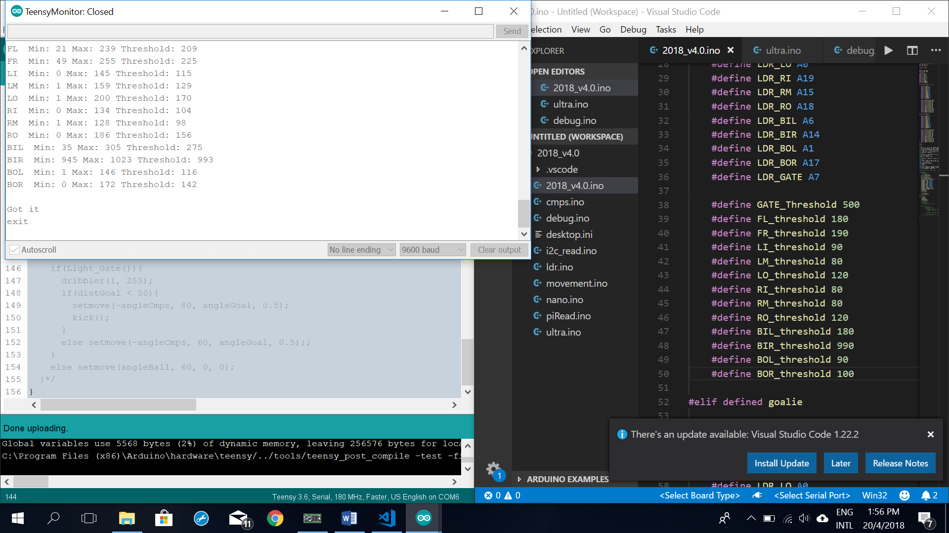

Competition goalie

FL Min: 74 Max: 282 Threshold: 252

FR Min: 103 Max: 323 Threshold: 293

LI Min: 73 Max: 228 Threshold: 198

LM Min: 102 Max: 391 Threshold: 361

LO Min: 89 Max: 348 Threshold: 318

RI Min: 61 Max: 228 Threshold: 198

RM Min: 24 Max: 264 Threshold: 234

RO Min: 70 Max: 276 Threshold: 246

BIL Min: 86 Max: 365 Threshold: 335

BIR Min: 38 Max: 221 Threshold: 191

BOL Min: 84 Max: 356 Threshold: 326

BOR Min: 27 Max: 289 Threshold: 259

    #define GATE_Threshold 200

    #define FL_threshold 220

    #define FR_threshold 260

    #define LI_threshold 140

    #define LM_threshold 300

    #define LO_threshold 260

    #define RI_threshold 140

    #define RM_threshold 180

    #define RO_threshold 180

    #define BIL_threshold 280

    #define BIR_threshold 140

    #define BOL_threshold 260

#define BOR_threshold 200

Competition Striker burnt out lights

FL Min: 69 Max: 199 Threshold: 169

FR Min: 99 Max: 257 Threshold: 227

LI Min: 30 Max: 99 Threshold: 69

LM Min: 17 Max: 152 Threshold: 122

LO Min: 19 Max: 214 Threshold: 184

RI Min: 28 Max: 120 Threshold: 90

RM Min: 21 Max: 119 Threshold: 89

RO Min: 18 Max: 127 Threshold: 97

BIL Min: 17 Max: 287 Threshold: 257

BIR Min: 173 Max: 1017 Threshold: 987

BOL Min: 23 Max: 156 Threshold: 126

BOR Min: 21 Max: 75 Threshold: 45

    #define GATE_Threshold 500